CALLING ALL
CITY OF UMATILLA
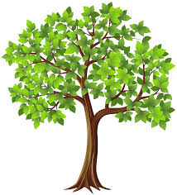
RESIDENTS!
Celebrate Arbor Week!
Schedule of Events:

Monday 04/16/18: Photo contest. Submit your best Umatilla tree photo to esmeralda@umatilla-city.org
Tuesday 04/17/18: Get out and walk the City, attempt to identify at least 5 different trees.

Wednesday 04/18/18: Umatilla City Library read about
Arbor Day @ 10:45 am

Thursday 04/19/18: City of Umatilla partners with
Umatilla School District to celebrate Earth Day and Arbor Day

Friday 04/20/18: Submit entry for tree give-away at City Hall by 5pm.

Winners for photo contest, coloring contest grades K-5, and tree giveaway winners will be announced on
Arbor Day, April 27, 2018 @ Village Square Park at 2pm
For more information call 541-922-3226 x 108.

