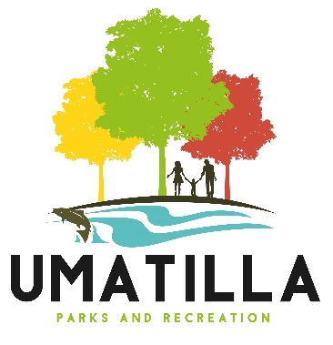
Volunteer Registration Form
Mail or Hand deliver your completed application to:
Umatilla Parks and Recreation Department
700 6th Street
Umatilla, OR 97838

Please print legibly and fill out completely:
Name: (print legibly)
Address:
City: |  | State & Zip:
Mailing Address:
(if different from physical address)
Phone Number: |  | Email:
Age: |  | Driver’s license or ID#:  (if applicable)
Emergency Contact: |  | Emergency Contact  Phone Number:

Please let us know what type of events you would like to help in:

Do you have any skills that may be beneficial for events the city hosts? If yes, please list below:

Have you helped at any City of Umatilla events before? Yes | No
If yes, which ones?

What days would you be available?
Sunday Monday Tuesday Wednesday Thursday Friday Saturday

Would you be available in the…?
morning? Yes | No
afternoon? Yes | No
evening? Yes | No

How comfortable would you be being in charge of an area on your own (ex. a booth, bounce house, or activity)?
1 2 3 4 5
Not Comfortable | Comfortable

How would you rate your interpersonal skills?
1 2 3 4 5
Okay | Exceptional

How often would you like to volunteer?
3-5 times per month 1-2 times per month
Other
Once every 2 months

I hereby certify that the above information is correct to the best of my knowledge and I understand that by agreeing to volunteer with the City of Umatilla, Parks and Recreation department that I consent to being contacted by an employee of the city during reasonable hours to ascertain my availability for city hosted events throughout the year for the foreseeable future and that if I no longer wish to be contacted for volunteer activities with the city I will have to contact an employee of the city to rescind my information.
Signature of applicant: | Date:

*******************************************************************
OFFICE USE ONLY
Date Received: |  | Received By:

